GISEL

Game of International Supply chain for Efficient Logistics

Created by:
Besançon-Vesoul IUT –Transport-Logistics Department

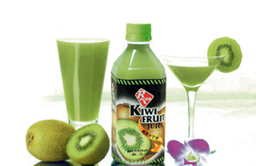

Logistics covers the total distribution flows within a company. GISEL simulates these flows providing an introduction to and practice of logistics. The player assumes the position of the Logistics Manager of a fictitious manufacturing firm, called “WIKI”, such that he or she has to manage and coordinate the provision, production, warehousing, transport and distribution activities of several products described and sold in various regions. The environmental impact of the company will be taken into account too and even if the manager’s objective is to make maximum profit, he also has to reduce the greenhouse gas emissions as much as possible.

This file will enable you to know WIKI better as it contains all the data of the starting situation, at the beginning of March 2025, when you officially start your job as Logistics Manager.

You will be in charge of the Management of the flows within WIKI for a minimum of 8 months.

For each of these months you will have to make decisions about the provision of raw materials, production management and distribution to the various warehouses. You will then enter your decisions on the computer and the software GISEL will automatically generate the demand for each finished product made by the warehouses for the relevant month, and it will then simulate the operations within WIKI -taking your captured data into account- and will give you the new physical and financial situation of the company as well as its carbon dioxide footprint, under the form of a listing.

Your management skills will then be assessed through the results generated by your decisions. These results will be determined through a set of activity and economic indicators which will analyse the whole supply chain.

Important notes:

While you manage the company, unpredictable events can happen anytime –breakdowns, strikes, fires in the warehouses…

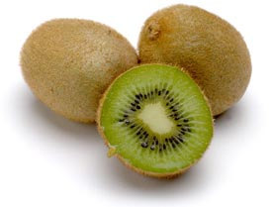
Detailed presentation of WIKI

You are the Logistics Manager of WIKI.  This international company produces and markets two types of finished products: kiwi nectar in packs and cordial in bottles.  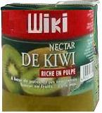 | 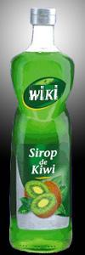

The company owns 3 factories located on 2 continents and in 3 different countries.

New Zealand: Auckland
France: Vesoul
Netherlands: Arnhem

The factory located in Auckland produces 2 kinds of raw materials: kiwi puree and kiwi concentrate. | 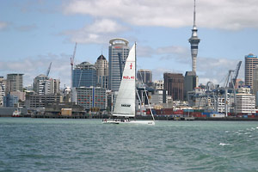

They are stored in bins first and then in refrigerated containers to be transported to Europe by maritime and rail transport.

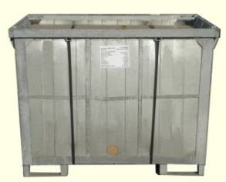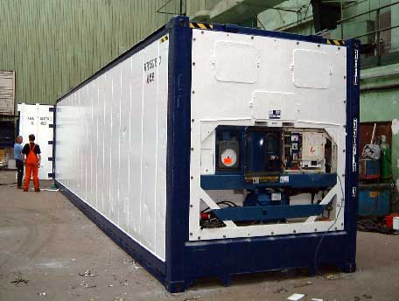

Arnhem factory produces kiwi nectar made of puree and concentrate which is then packaged in packs.  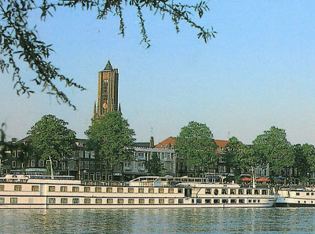 | 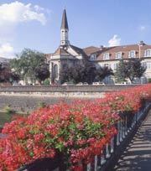
 | The factory situated in Vesoul manufactures kiwi cordial made of concentrate and sugar which is packaged in bottles.

These finished products are then sent on pallets, by road, to the warehouses located in 10 European cities which are the origins of the orders.

STARTING DATA
Situation of the company on 1st March 2025

- International transport

1.1 Finished products

The finished products are the nectar in packs and the cordial in bottles, respectively manufactured in Arnhem and Vesoul and are ready for sale.
They are packed on euro-pallets with the following characteristics:

 | weight (kilogramme) | height (metre)
Nectar (pallet) | 350 kg | 1
Cordial (pallet) | 500 kg | 1.20

The prices of these pallets vary according to the warehouse. They are listed in 1.5.

1.2 Means of transport

The distribution of the finished products manufactured in Arnhem and Vesoul to the 10 warehouses is carried out by a maximum of 3 chartered lorries. Each lorry starts and ends its round in the same city. Similarly, the same driver is assigned to each lorry. Lorries 1 and 2 are identical double decking semi-trailers. Lorry 3 is smaller but it is electric and therefore doesn’t emit carbon. Here are the characteristics of these vehicles:
Characteristics | Lorry n°1 | Lorry n°2 | Lorry n°3
City | Arnhem | Vesoul | Paris
Maximum payload in tonnes | 25 | 25 | 15
Maximum number of pallets | 66 | 66 | 24
Average speed (breaks included) in km/h | 60 | 60 | 50
Cost, all included (wages, fixed and variable costs) per km in € | 2.5 | 2 | 1
Carbon emission rate in kg / km | 0.920 | 0.920 | 0
Maximum driving and handling time per month in hours | 500 | 250 | 150
Drivers | Anne-Chantal, Samy | Veronika | Freddy

1.3 Handling time

The handling time of the products and the time dedicated to the processing of administrative documents are included in the working time of the drivers and amounts to 0.03 hour (1mn 48s) for the loading of a pallet. The same computation is to be applied to the unloading of a pallet.

1.4 Geographic distribution

The finished products are distributed from Arnhem and Vesoul to the 10 warehouses located in Paris, Rauma, Madrid, Milan, Rome, Bucharest, Budapest, Kemijärvi, Warsaw and Berlin.

If, in a given month, a warehouse has not been supplied with the right quantity of products to meet the customers’ demand, they will temporarily find another supplier and will not ask for the products which they have not been able to buy previously.

Here is the matrix of the distances between the various cities:

distance (km) | Arnhem factory | Vesoul factory | Berlin | Bucharest | Budapest | Kemijärvi | Madrid | Milan | Paris | Rauma | Rome | Warsaw
Arnhem factory |  | 637 | 597 | 2197 | 1301 | 2597 | 1764 | 979 | 509 | 1771 | 1577 | 1134
Vesoul factory | 637 |  | 967 | 2120 | 1224 | 3106 | 1527 | 484 | 360 | 2282 | 1081 | 1504
Berlin | 597 | 967 |  | 1660 | 871 | 2309 | 2324 | 1028 | 1408 | 1483 | 1523 | 561
Bucharest | 2197 | 2120 | 1660 |  | 796 | 3318 | 3187 | 1628 | 2284 | 3020 | 1895 | 1189
Budapest | 1301 | 1224 | 871 | 796 |  | 2813 | 2541 | 982 | 1495 | 2193 | 1249 | 696
Kemijärvi | 2597 | 3106 | 2309 | 3318 | 2813 |  | 4357 | 3305 | 3092 | 832 | 3772 | 1952
Madrid | 1764 | 1527 | 2324 | 3187 | 2541 | 4357 |  | 1564 | 1274 | 3528 | 1967 | 2879
Milan | 979 | 484 | 1028 | 1628 | 982 | 3305 | 1564 |  | 844 | 2481 | 584 | 1564
Paris | 509 | 360 | 1408 | 2284 | 1495 | 3092 | 1274 | 844 |  | 2266 | 1423 | 1603
Rauma | 1771 | 2282 | 1483 | 3020 | 2193 | 832 | 3528 | 2481 | 2266 |  | 3115 | 1308
Rome | 1577 | 1081 | 1523 | 1895 | 1249 | 3772 | 1967 | 584 | 1423 | 3115 |  | 1815
Warsaw | 1134 | 1504 | 561 | 1189 | 696 | 1952 | 2879 | 1564 | 1603 | 1308 | 1815

1.5 Prices and sales history

After an inventory and an even allocation of the unsold products in February 2025, each warehouse currently has 10 pallets of each product in stock.
For all the warehouses, the monthly storage cost of a pallet of kiwi nectar amounts to €12 and for a pallet of kiwi cordial it amounts to €19.

You will find the sales history from March 2023 to February 2025 for each warehouse and for each product. All the quantities are given in pallets.
Moreover, the sales prices are mentioned per pallet.

 | Pallet | Price | mars-23 | avr.-23 | mai-23 | juin-23 | juil.-23 | août-23 | sept.-23 | oct.-23 | nov.-23 | déc.-23 | janv.-24 | févr.-24 | mars-24 | avr.-24 | mai-24 | juin-24 | juil.-24 | août-24 | sept.-24 | oct.-24 | nov.-24 | déc.-24 | janv.-25 | févr.-25
Berlin | Nectar | 1 000 € | 26 | 25 | 44 | 62 | 63 | 45 | 25 | 22 | 36 | 55 | 60 | 41 | 22 | 19 | 35 | 49 | 46 | 35 | 16 | 15 | 25 | 36 | 37 | 25
Berlin | Cordial | 1 600 € | 25 | 23 | 41 | 58 | 57 | 39 | 20 | 20 | 30 | 50 | 46 | 32 | 17 | 18 | 31 | 42 | 38 | 26 | 15 | 13 | 23 | 32 | 30 | 19
Bucharest | Nectar | 700 € | 40 | 43 | 47 | 41 | 37 | 32 | 20 | 16 | 15 | 16 | 17 | 26 | 35 | 34 | 36 | 34 | 28 | 22 | 18 | 15 | 12 | 12 | 14 | 20
Bucharest | Cordial | 1 300 € | 27 | 28 | 31 | 28 | 27 | 17 | 12 | 8 | 10 | 8 | 15 | 16 | 20 | 23 | 23 | 19 | 17 | 16 | 11 | 9 | 7 | 7 | 8 | 12
Budapest | Nectar | 900 € | 26 | 18 | 19 | 17 | 27 | 32 | 40 | 45 | 48 | 42 | 37 | 33 | 22 | 13 | 14 | 17 | 21 | 28 | 31 | 38 | 38 | 39 | 32 | 22
Budapest | Cordial | 1 500 € | 29 | 29 | 29 | 26 | 24 | 25 | 26 | 25 | 25 | 25 | 26 | 26 | 24 | 25 | 21 | 23 | 22 | 22 | 24 | 23 | 22 | 19 | 20 | 19
Kemijarvi | Nectar | 900 € | 23 | 27 | 32 | 28 | 30 | 26 | 27 | 22 | 22 | 21 | 19 | 25 | 27 | 28 | 29 | 29 | 27 | 27 | 25 | 21 | 20 | 19 | 22 | 23
Kemijarvi | Cordial | 1 500 € | 18 | 18 | 20 | 15 | 11 | 15 | 16 | 22 | 21 | 17 | 13 | 13 | 15 | 20 | 20 | 17 | 12 | 16 | 17 | 20 | 22 | 17 | 12 | 15
Madrid | Nectar | 1 000 € | 24 | 24 | 20 | 18 | 24 | 27 | 28 | 30 | 29 | 29 | 27 | 27 | 20 | 22 | 21 | 20 | 23 | 24 | 27 | 30 | 30 | 31 | 28 | 27
Madrid | Cordial | 1 600 € | 22 | 21 | 19 | 22 | 24 | 25 | 29 | 30 | 31 | 28 | 28 | 24 | 24 | 21 | 18 | 23 | 23 | 26 | 28 | 30 | 29 | 30 | 28 | 25
Milan | Nectar | 600 € | 13 | 14 | 15 | 17 | 15 | 11 | 13 | 10 | 10 | 11 | 12 | 16 | 13 | 16 | 18 | 15 | 15 | 14 | 11 | 13 | 12 | 13 | 14 | 14
Milan | Cordial | 1 200 € | 9 | 8 | 8 | 11 | 7 | 9 | 6 | 8 | 9 | 10 | 8 | 9 | 9 | 11 | 7 | 11 | 10 | 10 | 9 | 10 | 9 | 9 | 13 | 11
Paris | Nectar | 1 100 € | 21 | 20 | 16 | 15 | 14 | 18 | 22 | 21 | 17 | 14 | 16 | 18 | 22 | 23 | 19 | 16 | 17 | 19 | 24 | 22 | 21 | 16 | 16 | 18
Paris | Cordial | 1 300 € | 20 | 20 | 17 | 15 | 16 | 20 | 23 | 19 | 22 | 15 | 18 | 17 | 22 | 23 | 19 | 18 | 15 | 20 | 22 | 22 | 20 | 17 | 16 | 18
Rauma | Nectar | 700 € | 20 | 23 | 20 | 22 | 22 | 22 | 23 | 24 | 24 | 24 | 21 | 24 | 23 | 24 | 26 | 24 | 25 | 22 | 23 | 26 | 28 | 24 | 24 | 25
Rauma | Cordial | 1 300 € | 14 | 15 | 15 | 19 | 17 | 16 | 17 | 18 | 19 | 17 | 18 | 18 | 17 | 19 | 19 | 17 | 19 | 18 | 21 | 18 | 20 | 19 | 17 | 22
Rome | Nectar | 800 € | 22 | 20 | 20 | 19 | 22 | 20 | 23 | 25 | 23 | 22 | 22 | 20 | 21 | 22 | 23 | 22 | 23 | 26 | 27 | 26 | 27 | 26 | 25 | 21
Rome | Cordial | 1 400 € | 11 | 11 | 13 | 13 | 14 | 16 | 15 | 16 | 14 | 14 | 11 | 18 | 14 | 15 | 14 | 16 | 15 | 18 | 15 | 17 | 16 | 17 | 17 | 19
Warsaw | Nectar | 1 000 € | 0 | 0 | 0 | 0 | 0 | 0 | 0 | 0 | 0 | 0 | 0 | 0 | 0 | 0 | 1 | 1 | 3 | 4 | 4 | 6 | 6 | 6 | 9 | 9
Warsaw | Cordial | 1 600 € | 0 | 0 | 0 | 0 | 0 | 0 | 0 | 0 | 0 | 0 | 0 | 0 | 0 | 0 | 1 | 2 | 3 | 4 | 5 | 4 | 6 | 6 | 8 | 10

- Intercontinental Transport

  - Organisation

The main raw materials, kiwi puree and kiwi concentrate, supplying the factories in Arnhem (the Netherlands) and Vesoul (France), come from Auckland (New-Zealand). These products are packed in bins which are stacked in refrigerated containers. They are mostly carried by boat, then by rail.

  - Cost and delivery time

It costs €200 per bin to be carried from the factory in New-Zealand to the European factories. Transport, which is mainly maritime, takes 2 months and emits 190 kg of CO₂ per bin.

Here are the ongoing orders:

Product | Puree  (bin) | Concentrate  (bin) | Concentrate  (bin)
Destination | Arnhem | Arnhem | Vesoul
Delivery within 1 month: quantity | 50 | 10 | 40

- Production

The lead time for each item manufactured by WIKI is 1 month.
The monthly storage rate for all the products and all the factories is 2%.

  - Arnhem factory

There are 6 employees currently working in this factory.

Nectar processing

The production of a batch of 30 pallets of nectar in packs costs €100 (wages excluded) and requires:
- 1 vat of nectar
- 1 batch of packs
- 20h of work
It produces 500 kg of CO₂.

Nectar production

The production of 1 vat of nectar costs €300 (wages excluded) and requires:
- 5 bins of puree
- 1 bin of concentrate
- 100h of work
It emits 2,000 kg of CO₂.

Stock status:

 | Nectar  (pallet) | Nectar  (vat) | Puree  (bin) | Concentrate  (bin) | Packs  (batch)
Currently available stock | 300 | 10 | 50 | 10 | 10

  - Vesoul factory

There are 6 employees currently working in this factory.

Cordial processing

The production of a batch of 20 pallets of cordial in bottles costs €100 (wages excluded) and requires:
- 1 vat of cordial
- 1 batch of bottles
- 20h of work
It produces 500kg of CO₂.

Cordial production

The production of 1 vat of cordial costs €300 (wages excluded) and requires:

- 4 bins of concentrate
- 1 tonne of sugar
- 100h of work
It emits 2,000 kg of CO₂.

Stock status:

 | Cordial  (pallet) | Cordial  (vat) | Concentrate  (bin) | Sugar  (tonne) | Bottles  (batch)
Currently available stock | 200 | 10 | 40 | 10 | 10

  - Production of kiwi puree and concentrate in the Auckland factory

There are 5 employees currently working in this factory.

Pressing kiwis automatically leads to the simultaneous production of puree and concentrate in a proportion of 4 for 1. It is impossible to change this proportion. Nevertheless, it is possible to sell the puree and concentrate at cost price, i.e. respectively €2,000 and €3,000 a bin.

The simultaneous production of 4 bins of puree and 1 bin of concentrate, as well as the purchase of the necessary fruits, costs €10,000 (wages excluded) and requires 50h of work. This production emits 10 tons of CO₂. A detailed analysis of the value has shown that the cost of a bin of puree amounts to €2,000 and the cost of a bin of concentrate to €3,000.

Stock status:
 | Puree  (bin) | Concentrate  (bin)
Currently available stock | 60 | 15

  - Purchases

The delivery time of the various items is 1 month.

Instead of using kiwi puree and kiwi concentrate produced in Auckland, it is possible to buy these products directly from a European supplier.
The delivery time is one month instead of two but the products are more expensive.

Here are the prices per unit given by the Italian supplier:

Product | Puree  (bin) | Concentrate  (bin)
Price | 6000 € | 9000 €
Cost in CO₂ | 3100 kg | 4400 kg

Here are the prices of raw materials per unit:

Product | Pack  (batch) | Bottle  (batch) | Sugar  (tonne)
Price | 1000 € | 3000 € | 400 €
Cost in CO₂ | 900 kg | 4000 kg | 300 kg

  - Human Resources

The employees of the factories in Arnhem and Vesoul can both process or package the beverages.
In spite of the geographical differences of the production sites, the personnel are treated in the same way, whatever the factory they work in. The labour cost for the company amounts to €3,000 per worker. Each worker cannot work for more than 150 hours per month. If an employee works less than 150 hours, the cost for the company will still amount to €3,000.
It is possible to hire or lay-off personnel. Such decisions will take effect in the following month. It costs €2,000 either to hire or lay-off someone.

 | 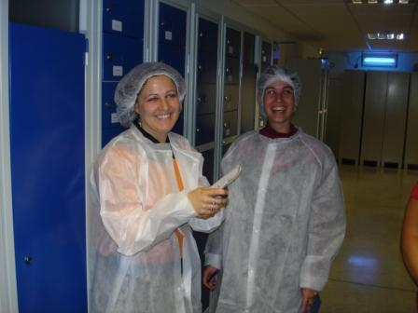  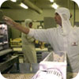 | 

- Preparatory work:

  - Complete the map describing WIKI’s distribution network (appendix 1)

  - Establish the bill of materials of both finished products, giving the assembling ratios and the cycle time for each level (appendix 2).

  - Mention the following parameters on the graph representing the flows (appendix 3) :
- Stock level,
- Normal time capacity of the workshops.

  - Calculate the total time load induced in the factory in Arnhem by:
- the packaging of 120 pallets of kiwi nectar,
- the production of 9 vats of nectar

How many employees are needed to perform these tasks?
Is it possible to do these operations for the first decision?

  - For the first decision, is it possible to package 330 pallets of nectar in Arnhem? Give 2 reasons!

  - For the following round :
Loading 60 pallets of nectar in Arnhem, then unloading 20 pallets in the warehouse in Kemijärvi and 40 pallets in Bucharest, then trip back to Arnhem.
- Check that loading is possible
- Compute the distance
- Compute the driving time
- Compute the handling time (loading + unloading)
- Compute the total working hours

  - 30 pallets of nectar and 20 pallets of cordial are sold in Madrid, what will be the corresponding turnover?

  - For each truck design a tool to check easily how many pallets you can load.

  - Forecast the sales of nectar and cordial in each town for each month from March 2025 to February 2026.

  - Analyse the method to manage WIKI in the best possible conditions. You will especially have to think about the various tasks you will have to carry out. Making a decision means filling the form of appendix 4.

APPENDIX 1

WIKI’S DISTRIBUTION NETWORK

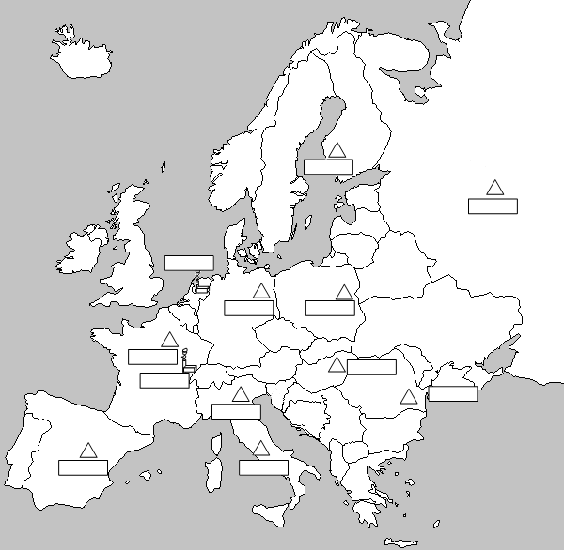

APPENDIX 2

BILL OF MATERIALS

vat
vat

APPENDIX 3: PHYSICAL FLOW CHART
APPENDIX 4

Filling form

APPENDIX 1

  - Complete the map describing WIKI’s distribution network (appendix 1)

Madrid
Vesoul
Paris
Roma
Milan
Bucharest
Budapest
Warsow
Berlin
Arnhem
Rauma
Kemijärvi

  - Establish the bill of materials of both finished products, giving the assembling ratios and the cycle time for each level (appendix 2).

APPENDIX 2

1
4
vat
1
1
vat
1
1
1
1
2
2
2
1
1
5
1
1
1
1
1
1

  - Mention the following parameters on the graph representing the flows (appendix 2) : Stock level, normal time capacity of the workshops.

APPENDIX 3: PHYSICAL FLOW CHART
10
10
10
10
Packaged
nectar
200
300
10
10
40
10
10
50
Capacity :
750 hours
Capacity :
900 hours
Capacity :
900 hours
15
60

  - Calculate the total time load induced in the factory in Arnhem by:
- the packaging of 120 pallets of kiwi nectar
120 pallets = 4 * 30 pallets
The packaging of 120 nectar pallets needs 4 * 20h = 80h
- the production of 9 vats of nectar = 9 * 100h = 900h
How many employees are needed to do these works above?
980h / 150 = 6.53 employees
Is it possible to do that for the first decision ?
No, actually there are only 6 employees in the Arnhem factory.

  - For the first decision, is it possible in Arnhem to package 330 pallets of nectar? Give 2 reasons!
- The package of 330 nectar pallets needs 11 nectar vats.
But only 10 vats are available.
- The same problem occurs with the batches of packs (11 batches of packs are needed for 330 pallets and only 10 batches of packs are available).

  - For the following round :
Loading 60 pallets of nectar in Arnhem, then unloading 20 pallets in the warehouse in Kemijärvi and 40 pallets in Bucharest, then trip back to Arnhem.
- Check that loading is possible
First 60 is less than 66 pallets allowed in lorry 1 or 2.
Weight of 60 nectar pallets: 60 x 350 kg = 21 000 kg. We can use lorry 1 or 2 (but not 3).

- Compute the distance
Arnhem Kemijärvi Bucharest Arnhem
2597 + 3318 + 2197 = 8112 km

- Compute the driving time
8112 / 60 = 135.2 h

- Compute the handling time (loading + unloading)
60 x (0.03 + 0.03) = 3.6 h

- Compute the total working hours
135.2 + 3.6 = 138.8 h
Don’t forget to check that 138.8 < 500h (lorry 1) or < 250 h (lorry 2)

  - 30 pallets of nectar and 20 pallets of cordial are sold in Madrid, what will be the corresponding turnover?
30 x €1000 + 20 x €1600 = €62000

